Polyline Editor Application – Design Principles (HCI Based)
Course: Human Computer Interaction (CS-555)
Reference: Alan Dix – Chapter 5
Role: Design Phase – Design Principles & Interface Design

Introduction
The Polyline Editor Application is designed based on the principles of Interaction Design described in Chapter 5 of Alan Dix’s Human-Computer Interaction. The goal is to create a system that is user-friendly, efficient, and intuitive, allowing users to easily draw and edit polylines using simple mouse and keyboard interactions.
This document presents the design principles, interface structure, and interaction flow, showing a clear application of HCI concepts.
Interface Overview (UI Description)
The system consists of a drawing canvas, mouse-based interaction, and keyboard shortcuts. The design follows a minimalist approach.
Interaction Flow
- Press 'b' to begin
- Click to create points
- Drag to move points
- Press 'd' to delete
- Press 'r' to refresh
- Press 'q' to quit
UI Sketch

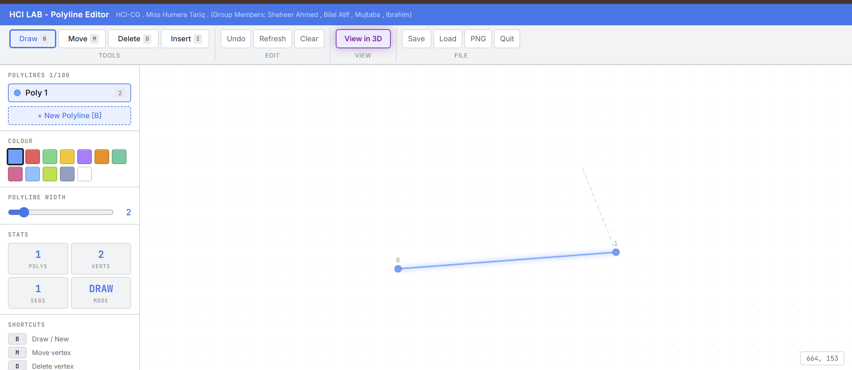

Design Principles
- User-Centered Design: Focus on user needs and simplicity.
- Visibility of System Status: Highlight selected points and show real-time updates.
- Direct Manipulation: Click and drag interactions.
- Consistency: Same actions produce same results.
- Feedback: Immediate response to actions.
- Error Prevention: Nearest point selection, undo possibility.
- Simplicity: Clean and minimal UI.
- Natural Mapping: Mouse movement reflects object movement.
- Learnability: Easy for new users.
- Iterative Design: Continuous improvement.
Design Process (Chapter 5)
- Requirements: Create/edit polylines
- Analysis: Add, move, delete points
- Design: Mouse + keyboard
- Evaluation: Test usability

Key Design Insights from Chapter 5 (Highlighted)
The following concepts are directly derived from Chapter 5: Interaction Design Basics (Alan Dix) and are explicitly reflected in this design:

1. User Focus (Core Concept of Chapter 5)
Chapter 5 emphasizes that design must be user-centered, focusing on user needs rather than system complexity.
Application in this system:
Simple click-based interaction
Minimal learning required
No complex commands

2. Iteration and Prototyping
Dix highlights that design is an iterative process, meaning it evolves through continuous improvement.
Application:
Initial version: basic polyline drawing
Improved version: smoother interaction
Future: undo, 3D editing, advanced UI

3. Navigation Design
Chapter 5 discusses the importance of clear and structured navigation.
Application:
Keyboard shortcuts (b, d, m, r, q)
Logical and easy-to-follow interaction flow

4. Screen Design and Layout
Good design requires proper layout, alignment, and simplicity.
Application:
Clean canvas interface
Minimal UI components
Focus on task (drawing)

5. Scenarios (Task-Based Design)
Dix explains that design should be based on user tasks and scenarios.
Application:
User drawing shapes step-by-step
Editing points through real interaction

Bonus (Extension Ideas)
Undo/Redo functionality
Save/Load polylines
3D polyline editing
Zoom and pan feature

Design Process for the Interactive Polyline Editor
We followed a user-centered iterative design approach:
1. Requirements Analysis: Identified four core interaction modes (Draw, Move, Delete, Insert) from the course specification, each requiring distinct visual feedback and cursor behavior.
2. Metaphor Selection: Adopted an MS Paint-inspired ribbon toolbar metaphor — familiar to users, reducing learning curve (HCI principle: leverage existing mental models).
3. Feedback Design: Every action produces immediate visual feedback — color-coded mode buttons, vertex glow on hover (red=delete, yellow=move, teal=insert), ghost preview lines, and toast notifications. This satisfies Nielsen's heuristic of visibility of system status.
4. Error Prevention: Auto-removal of polylines with < 2 points, max 100 polyline limit with user notification, and confirmation dialog on Quit.
5. Shortcuts & Efficiency: Single-key shortcuts (B/M/D/I/Z/R/ESC/Q) for expert users alongside clickable buttons for novices — supporting both *recognition and recall*.
6. Iterative Refinement: Moved from dark theme → light MS Paint theme based on feedback, adjusting layout, color tokens, and typography for professional appearance.

Deliverables (with respect to Design Phase)
As part of the Design Phase (based on Chapter 5 – Interaction Design Basics by Alan Dix), the following deliverables were produced:
- A user-centered interface design for the Polyline Editor Application
- A low-fidelity UI sketch representing the layout of the system
- A clear interaction flow, showing how users perform tasks such as creating, moving, and deleting points
- Application of key design principles including:
  - Direct manipulation
  - Consistency
  - Feedback
  - Simplicity
- Identification of keyboard controls and navigation structure for efficient interaction
These deliverables reflect the transformation of requirements and analysis into a structured design solution, as emphasized in Chapter 5.

Challenges Faced
During the design process, several challenges were encountered:
- Translating theoretical HCI principles into a practical interface design
- Ensuring simplicity while still supporting all required functionalities
- Maintaining consistency across different user interactions (mouse + keyboard)
- Designing an interface that provides real-time feedback without complexity
- Understanding how to apply iteration in a small-scale academic project
These challenges reflect the real-world difficulty of applying interaction design concepts effectively.

Lessons Learned
This task provided valuable insights into interaction design:
- The importance of user-centered design, where user needs come before system logic
- How direct manipulation improves usability and user engagement
- The role of feedback and visibility in reducing user confusion
- The significance of iteration, as design improves through refinement
- How proper navigation design simplifies user interaction
Overall, this task strengthened the understanding of how theoretical concepts from Chapter 5 can be applied in real systems.

Final Conclusion
The Polyline Editor Application strongly reflects the principles of Interaction Design described in Chapter 5 of Alan Dix. Key concepts such as user-centered design, iterative development, navigation design, and simplicity have been effectively applied.
This demonstrates a clear and practical understanding of HCI concepts, ensuring that the system is not only functional but also highly usable, intuitive, and efficient.

